


Izadi lights Christmas in
Puerta del Sol
* The DOCa Rioja winery presents its Izadittone in the heart of the in the heart of Madrid to coincide with the start of the Christmas lights

Villabuena de Álava, November 2024. Bodegas Izadi's Izadittone, one of the most awaited sweets, was presented yesterday to customers and specialized media while the city was illuminated with Christmas lights. This exclusive sweet from the Riojan winery is already part of the Christmas gastronomy lovers and, this year, it has celebrated its first Izadittone Christmas Party in the heart of Madrid.

Christmas arrives with Izadittone. Izadi begins these special dates with the presentation in society of its Izadittone, which, on this occasion, has had its own welcome party, coinciding with the lighting of the Christmas lights in the capital of Madrid in Puerta del Sol. The winery celebrated this party with friends, restaurateurs, journalists... in a unique location to watch the lighting of the lights.
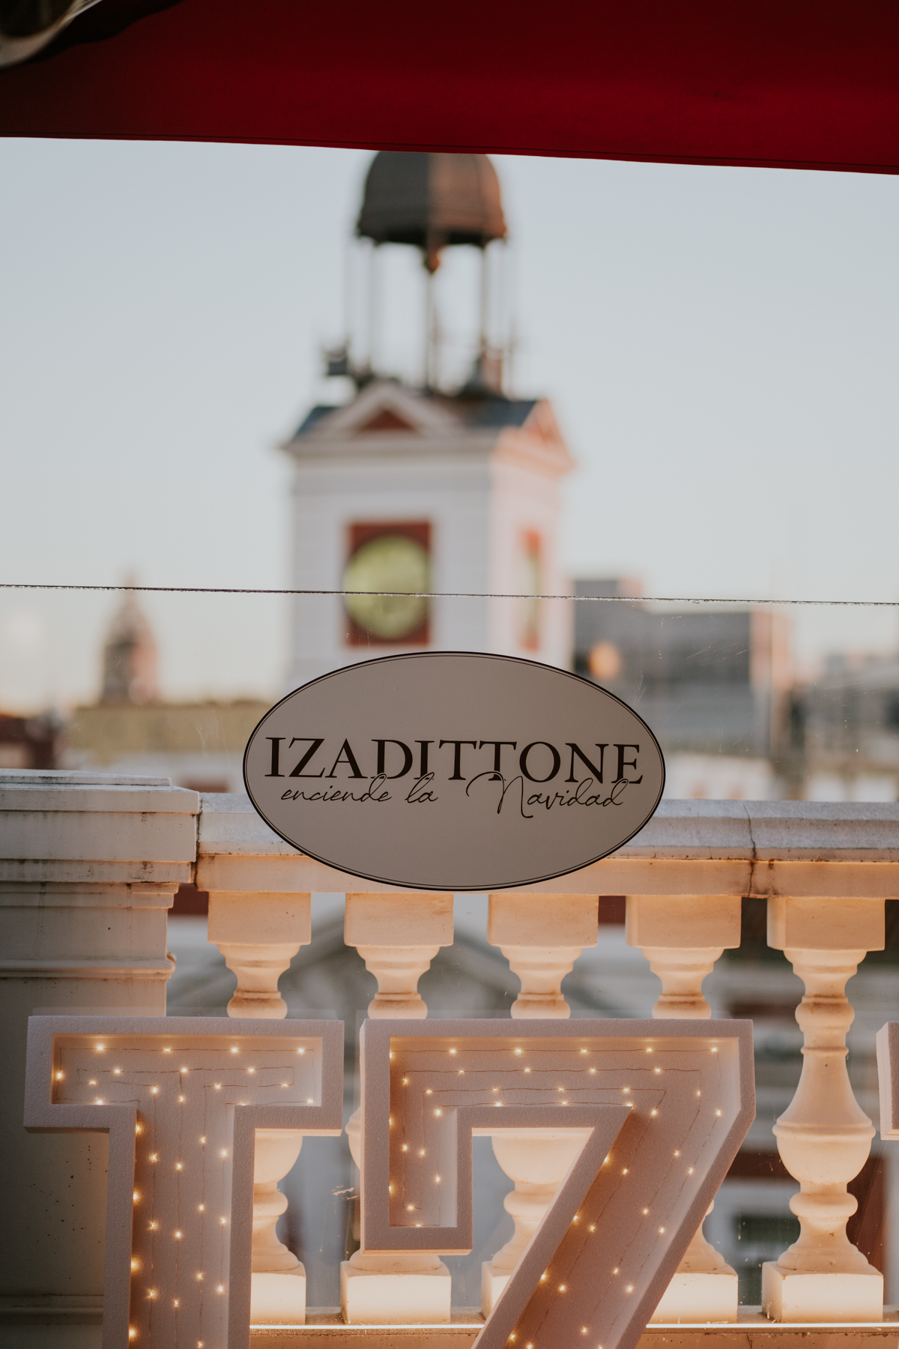
From the top of Puerta del Sol, all the guests were able to enjoy unique views of this central square and the lighting of the lights that had as a special guest the national soccer coach, Luis de la Fuente, in charge of starting the countdown and pressing the button that illuminated Madrid. Also from the top of Puerta del Sol, they could enjoy the performance of Álvaro de Luna and a moving tribute to the victims of the Dana of Valencia with a children's choir.

During this Christmas party, attendees also enjoyed some of the winery's most representative wines, with the final touch of a toast with its singular vineyard, El Regalo.

Izadi wanted to highlight this project that began as an anecdote and has become a tradition for the DOCa Rioja winery. A collaboration, hand in hand, with the Italian bakery Loison, located in Vizenza (Italy), one of the most prestigious in Italy, for the quality of its chocolates, its good work and its trajectory.

The elaboration of this sweet has become for Izadi a Christmas tradition that cannot be missed and is another step in its commitment and union with gastronomy, the discipline where this winery from Alava was born by the Antón family.

At Christmas 2017 the first Izadittones arrived and their success was such that both the Italian brand Loison and Bodegas Izadi decided to continue their relationship to create this very special sweet every year. So much so that they created two different versions: Izadittone Classic which, with aged pomace, is a tribute to the traditional Italian recipe to which raisins, orange and lemon are added, and the Izadittone with which this adventure began a few years ago and which features Bodegas Izadi grape pomace and chocolate.

Izadittone, the panettone unique in Spain, is made with pomace cream obtained from the distillation of the skins of the grapes from the winery and with the recipe - more than 90 years old - of the sourdough of the Italian company Loison, considered the Ferrari of panettones thanks to its know-how since 1938.

Izadittone can now be purchased at www.artevinostore.es and gourmet stores.

PVP: 32,90€

https://artevinostore.es/catalogo/regalos/izadittone-panettone-crema-orujo

Notes: Bodegas Izadi was founded in 1987 by Gonzalo Antón, a renowned hotelier from Vitoria. Currently, his son Lalo Antón runs this winery, parent company of Artevino Family Wineries (Finca Villacreces, Bodegas Vetus and Orben). Izadi is located in Villabuena de Álava, in the heart of the Rioja Alavesa. Restlessness, sensitivity, hospitality and respect mark the way of understanding the 187 hectares of old vineyards it manages. Its wines: Larrosa Rosé, Larrosa Blanca, Larrosa Negra, Izadi Selección and Izadi El Regalo VS. In 2023 it received the Best Of of wine tourism for its sustainable practices.
For more information:
Finca Villacreces- Iván Pérez – iperez@artevino.es - 616 510 586
10vcomunicación – Victoria Díez - victoria@10vcomunicacion.es - 629 682 802

